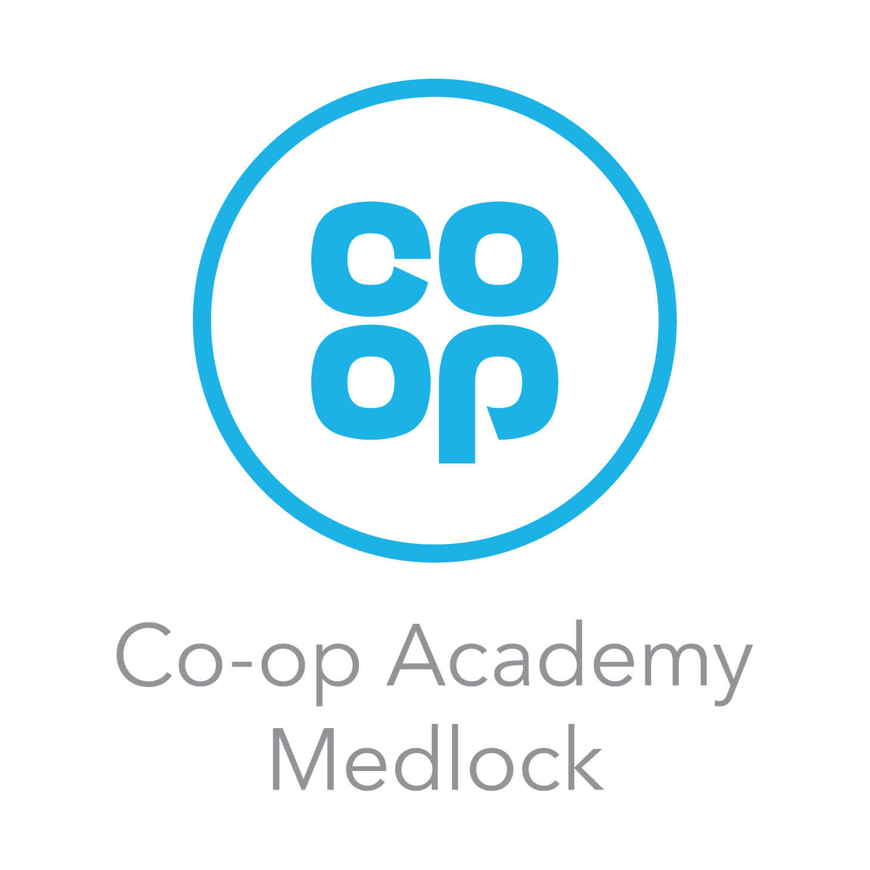 Co-op Academy Medlock Year 5 Overview - Summer 2

Do What Matters Most | Be Yourself, Always | Show You Care | Succeed Together

English  This half term, Year 5 will be writing a narrative involving a dilemma. We will also be writing a balanced argument later in the half term. Lessons will continue to begin with sentence accuracy work. In Shared Reading, we will continue to develop a range of reading skills through fiction, non-fiction and poetry. We will continue to develop spelling skills. | Maths  This half term, children will be expanding their knowledge of fractions, decimals and percentages equivalents, geometry, negative numbers and capacity. Arithmetic work will continue to focus on practising and securing core knowledge.

History/ Geography  This half term, the children will continue with a geographical focus during Theme lessons, as we complete our studies about human and animal migration. Once completed, we will be learning Ellen Wilkinson in a History unit. | Science  This half term, Year 5 will be learning about Space.

RE  This half term’s big question is  ‘How can people express the spiritual through art and music?’ | PSHE  Using the Kapow scheme of work, this half term will continue to focus on citizenship, rights and responsibilities. | Computing  The half term will always begin with E-safety. This half term’s focus will further develop skills in and understanding of digital wellbeing. The children will also continue to use Scratch to develop their coding skills, building on knowledge and understanding transferred from using Discovery Education’s block coding. In our digital and multimedia work, we will be looking at what a search engine is and using Google effectively to search, narrowing search results and identifying safe websites.

Art  This half term’s Art will be developing knowledge, skills and understanding to complete a piece of collage work, linked with Manchester and its changing population thanks to migration.  DT  Upon completion of the Art unit, we will be designing and making a planet themed light. | Spanish  We will be completing last half term’s theme of ‘Out of this World’ followed by our final unit about ‘Going to the Beach’. The children will learn and practise some related vocabulary. They will continue to look at masculine and feminine nouns and how noun gender affects adjective endings. They will also build upon previous learning to describe places. | PE  During the half term, children will focus on developing different skills for varying athletics events.  The children will need suitable footwear for outdoor PE lessons.
Music
This half term, the children will resume building upon their understanding of simple rhythms and notation previously covered. Each child will continue to learn how to play the ukulele with Ms Kent.

